Skyline Absolute Quantification

# Introduction

This tutorial covers how to determine the absolute abundance of a target protein using Selected Reaction Monitoring (SRM) mass spectrometry. Specifically, we will demonstrate how to use an external calibration curve with an internal standard heavy labeled peptide.

Peptide absolute abundance measurements can be obtained using either a single-point or a multiple-point calibration. Single-point calibration absolute abundance measurements are generated by spiking into a target sample a heavy labeled ‘standard’ version of the target peptide that is of known abundance. The absolute abundance of the ‘sample’ target peptide is obtained by calculating the relative abundance of the light ‘sample’ target peptide to the heavy ‘standard’ target peptide1. One drawback is that this approach assumes that a light-to-heavy ratio of 2 implies that the light peptide is actually twice as abundant as the heavy peptide – this is referred to as having a peptide response with a slope of 1. Furthermore, this approach of using a single point calibration makes the assumption that both the light and the heavy peptide are both within the linear range of the mass spectrometry detector. However, these assumptions are not always correct2,3,4,5.

Multiple-point calibration experiments correct for situations where the peptide response does not have a slope of 1. This calibration is done by measuring the signal intensity of a ‘standard’ peptide at multiple calibration points of known abundance and generating a calibration curve. This calibration curve can then be used to calculate the concentration of the target peptide in a sample, given the signal intensity of that peptide in that sample3. One drawback is that this method requires multiple injections into the mass spectrometer to build a calibration curve.

To improve the precision of absolute abundance measurements using an external calibration curve, stable isotope labeled internal standards are often used6. Imprecise measurements of the ion intensity of a peptide often arise from sample preparation, autosampler or chromatographic irregularities. By adding an identical quantity of a standard heavy labeled peptide to each of the calibrants and the sample, one is able to measure the ratio of calibrant-to-standard or sample-to-standard. This approach is favored as this ratio is unaffected by some sample preparation, autosampler or chromatographic irregularities. Consequently, by performing peptide absolute quantification using an external calibration curve and an internal standard heavy labeled peptide one is able to obtain the most accurate and precise measurements while minimizing the amount of valuable sample that has to be used.

# Experimental Overview

This tutorial will work with data published in Stergachis et al.7 where the absolute abundance of GST-tagged proteins were measured using a ‘proteotypic’ peptide present within the GST-tag (**Tutorial Figure 1A**). For any absolute quantification experiment, it is critical to first identify one or more ‘proteotypic’ peptides that will be used to quantify the protein of interest. The peptide IEAIPQIDK was identified as ‘proteotypic’ based on its strong signal intensity relative to other tryptic peptides in the GST-tag (unpublished). Also, this peptide uniquely identifies this schistosomal GST-tag as opposed to other human glutathione-binding proteins.

For this experiment, FOXN1 protein containing an in frame GST-tag was generated using *in vitro* transcription/translation and full-length proteins were purified using glutathione resin (**Tutorial Figure 1B**). Heavy labeled IEAIPQIDK peptide was then spiked into the elution buffer and the sample was digested and analyzed using selected reaction monitoring (SRM) on a Thermo TSQ Vantage triple-quadrupole mass spectrometer. An external calibration curve was generated using different quantities of a light IEAIPQIDK peptide that was purified to >97% purity and the concentration determined by amino acid analysis. Heavy labeled IEAIPQIDK peptide was also spiked into these calibrants at the same concentration as in the FOXN1-GST sample (**Tutorial Figure 1C**). It is important to note that it does not matter what the concentration of the heavy peptide is in each of the samples, so long as it is the same. However, it is best if the amount of heavy peptide in the samples is similar to the amount of light peptide originating from FOXN1-GST. Also, it is best if the concentration of the light peptide originating from FOXN1-GST falls somewhere in the middle of the concentration range tested using the different calibrants.

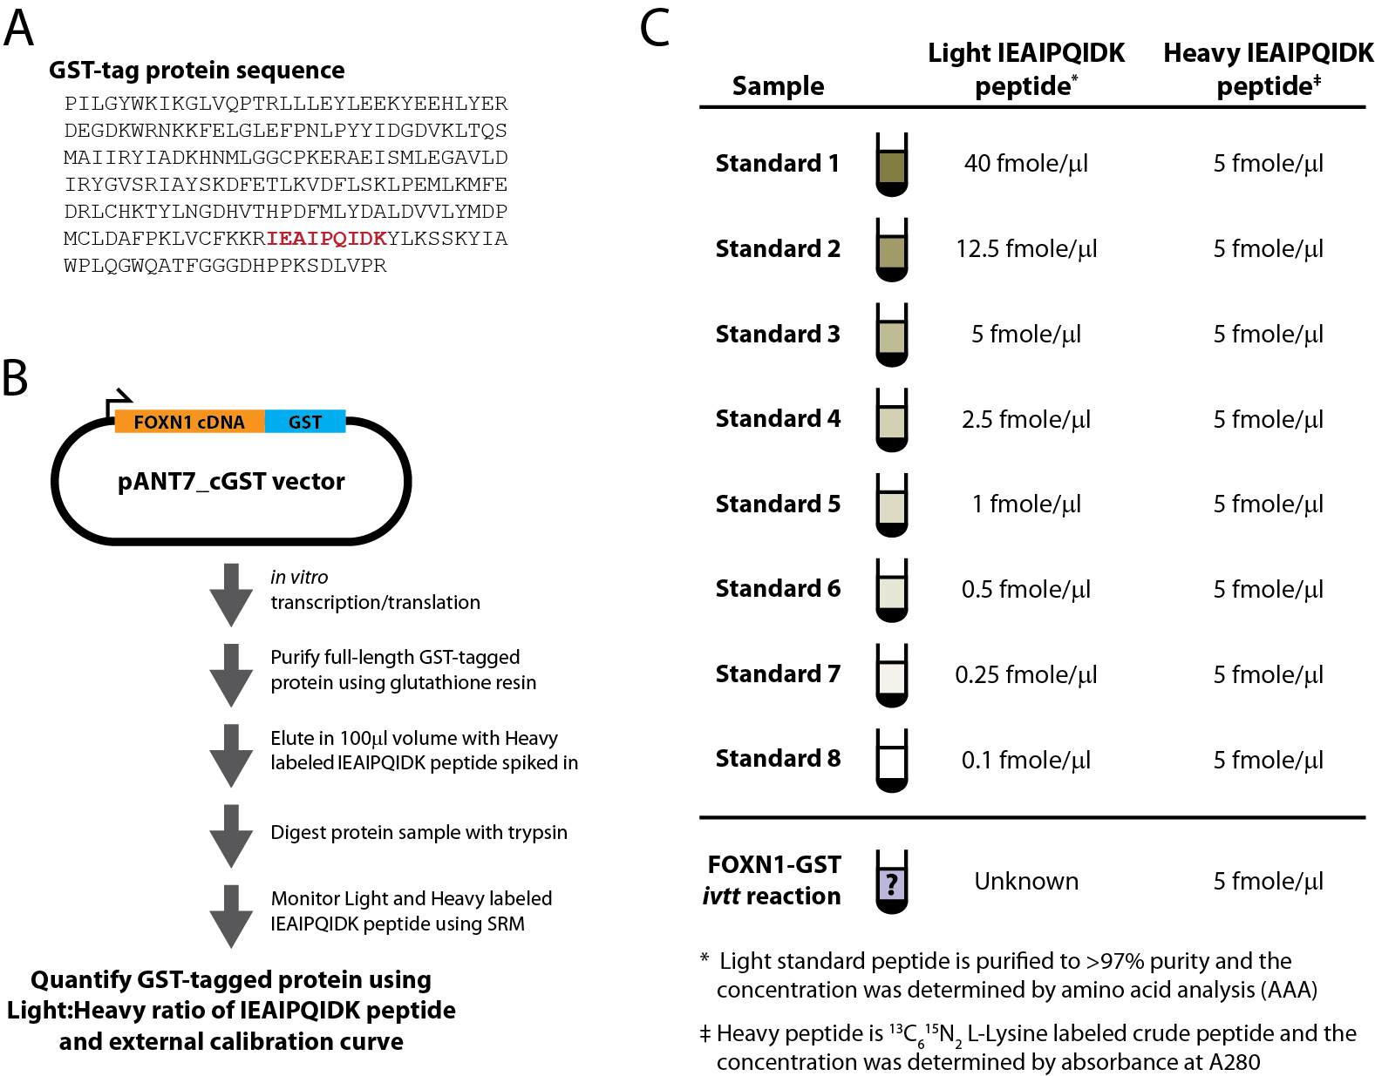

**Tutorial Figure 1. Experimental Overview**

(**A**) Schistosomal GST-tag protein sequence. The tryptic peptide used for quantification purposes is indicated in red.

(**B**) Schematic of the synthesis, enrichment, digestion and analysis of tagged proteins.

(**C**) Samples monitored and the abundance of light and heavy IEAIPQIDK peptide in each.

# Getting Started

To start this tutorial, download the following ZIP file:

<https://skyline.gs.washington.edu/tutorials/AbsoluteQuant.zip>

Extract the files in it to a folder on your computer, like:

C:\Users\absterga\Documents

This will create a new folder:

C:\Users\absterga\Documents\AbsoluteQuant

Now start Skyline, and you will be presented with a new empty document.

# Generating a Transition List

Before you insert a peptide sequence into Skyline, it is important to make sure that all of the peptide and transition settings are correctly configured for this experiment. The settings described below are designed for 13C615N2 L-Lysine labeled internal standard peptides. If you are using a different isotope, please choose the appropriate isotope modification in the Peptide settings configuration.

## Configuring Transition settings:

* On **Settings** menu, click **Transition Settings**.
* Click the **Prediction** tab.
* Choose **Monoisotopic** for the **Precursor mass** and the **Product ion mass**.
* From the **Collision energy** drop-list choose the instrument that you will be using for your measurements. For this experiment, a **Thermo TSQ Vantage** was used for all measurements.
* Click the **Filter** tab.
* For these experiments we monitored doubly charged precursors (**Precursor charges**), and singly charged (**Ion charges**) y3 to yn-1 product ions (**Ion types** and **Product Ions From** and **To**).
* The correct configuration of these tabs can be seen below.

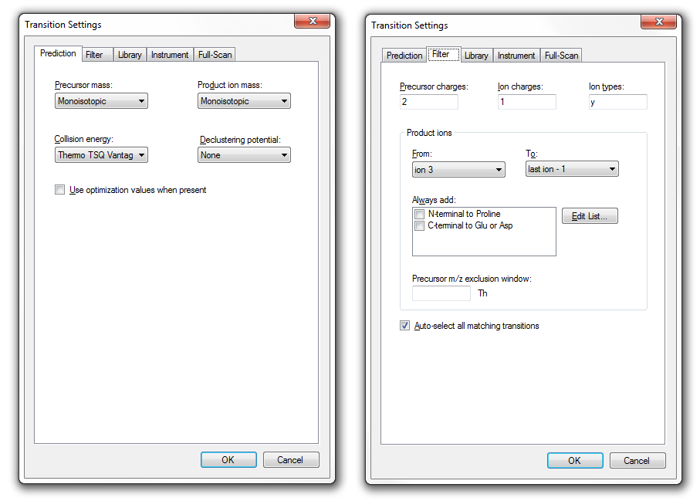

## Configuring Peptide settings:

* On the **Settings** menu, click **Peptide Settings**.
* Click the **Modifications** tab.
* Click the **Edit list** button for **Isotope modifications**.
* Click the **Add** button.
* Choose **Label:13C(6)15N(2) (C-term K)** from the **Name** dropdown list.
* Click the **OK** button.
* Check the new **Label:13C(6)15N(2) (C-term K)** modification in the **Isotope modifications** list.
* Since the experiment uses a heavy labeled internal standard peptide, ensure that the **Internal standard type** drop-list is set to **heavy**.

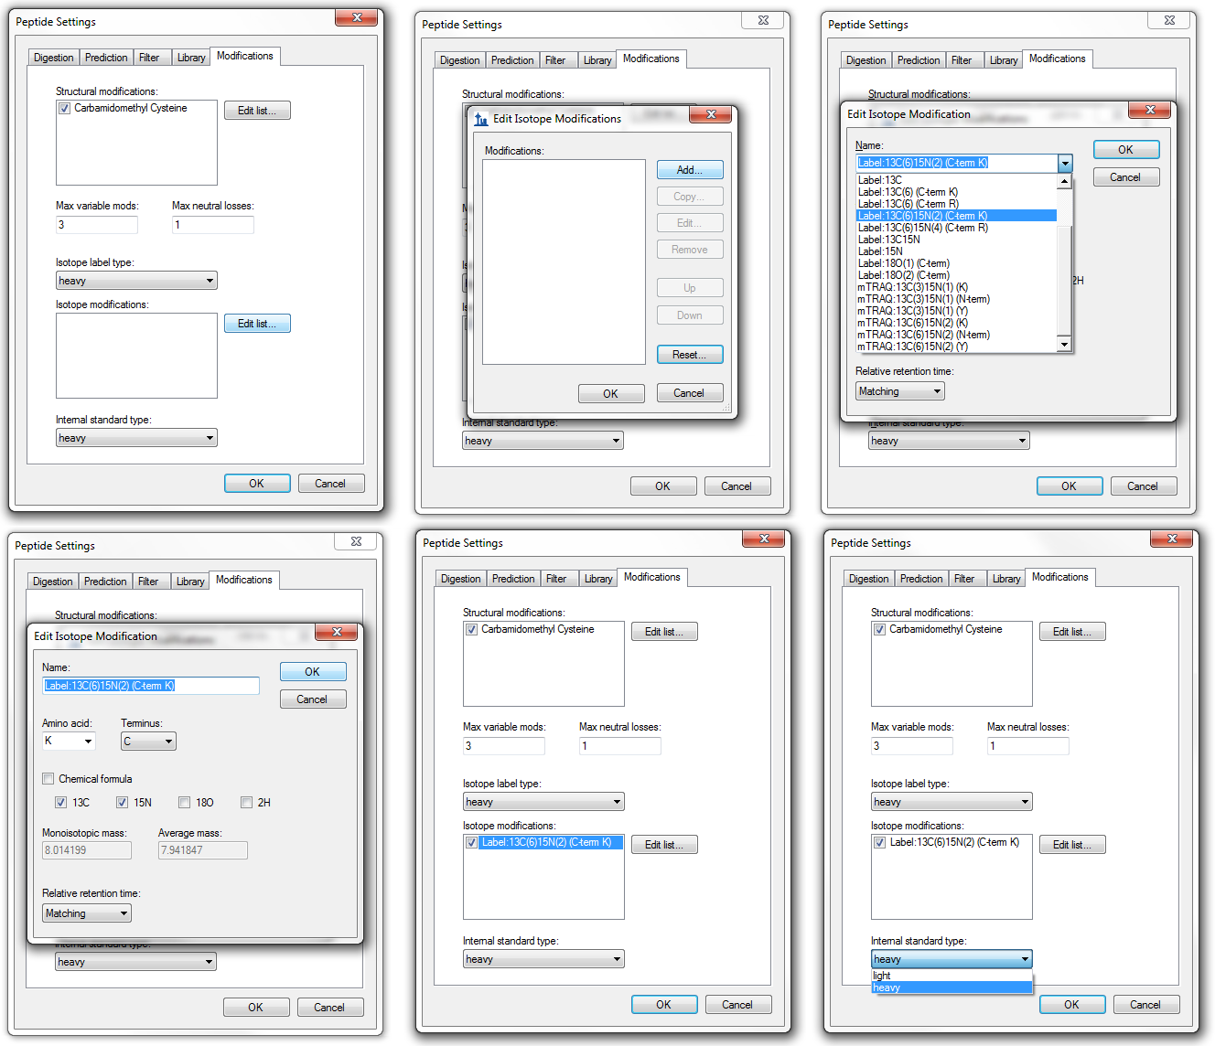

## Inserting a peptide sequence:

* On the **Edit** menu, choose **Insert** and click **Peptides**.
* Paste *IEAIPQIDK* into the **Peptide Sequence** box and *GST-tag* into the **Protein Name** box.
* Click the **Insert** button.

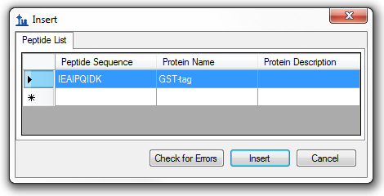

After performing the above steps, the main screen of Skyline should appear as below. You can save this file as test_file or whatever you like in the folder you have created for this tutorial.

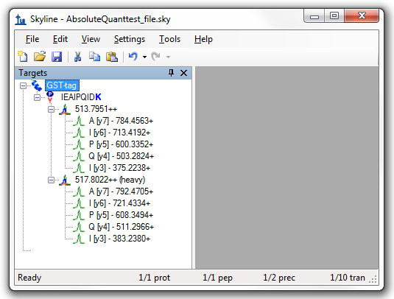

## Exporting a transition list:

* On the **File** menu, choose **Export** and click **Transition List**.
* The **Export Transition List** form can be configured as desired. Below is what was used for this experiment.
* This exported transition list was used to generate an SRM method for a Thermo TSQ Vantage triple-quadrupole mass spectrometer.

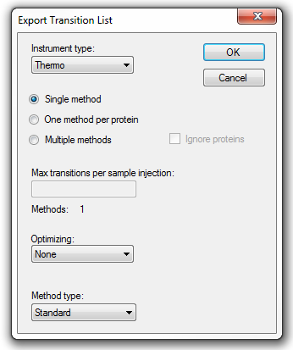

# Analyzing SRM Data from Calibrants

In this next section you will work with the nine samples indicated in **Tutorial Figure 1C**. You will import the .RAW files into Skyline to view the data. Data will be imported into the saved Skyline document that was generated in the previous section. The files that you will import are contained in the folder you created for this tutorial and are called:

* Standard_1.RAW
* Standard_2.RAW
* Standard_3.RAW
* Standard_4.RAW
* Standard_5.RAW
* Standard_6.RAW
* Standard_7.RAW
* Standard_8.RAW
* FOXN1-GST.RAW

These RAW files were collected in a random order and were interspersed among a larger set of runs. The results as fully processed with Skyline can be found in the **Supplemental Data 2** for the original paper (<http://proteome.gs.washington.edu/supplementary_data/IVT_SRM/Supplementary%20Data%202.sky.zip>).

Before you look at the FOXN1-GST sample, you should first become familiar with the standards.

## Importing RAW files into Skyline:

* On the **File** menu, choose **Import** and click **Results**.
* Click the **Add single-injection replicates in files** option in the **Import Results** form.
* Click the OK button.
* In the **Import Results Files** form, find and select all eight *Standard* RAW files listed above.
* Click **Open** to import the files.
* When presented with the option to remove the ‘Standard_’ prefix in creating replicate names, click **Do not remove**.

It may take a few moments for Skyline to import all of the RAW files.

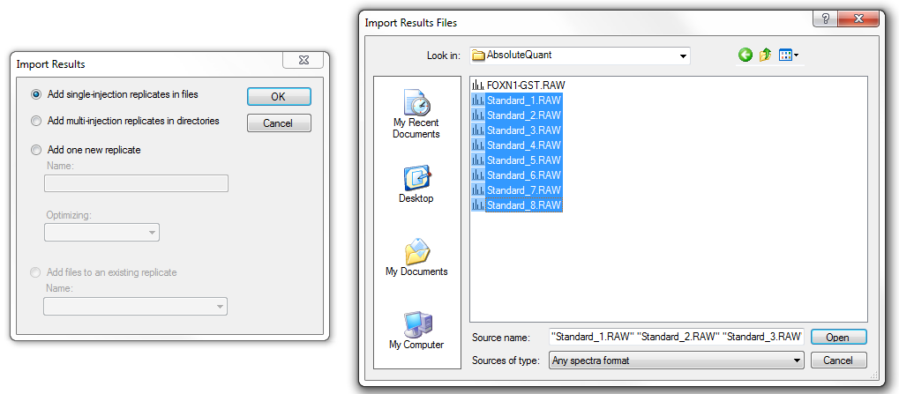

To ensure that the chromatographic peaks for each of the standards looks good, it is best to view all of the traces next to each other in a tiled view.

This can be done by clicking ctrl-T or on the **View** menu, by choosing **Arrange Graphs** and clicking **Tiled**.

If you select the IEAIPQIDK peptide on the left side of the screen, you will see the heavy (Blue) and light (Red) traces loaded into the same window for each standard.

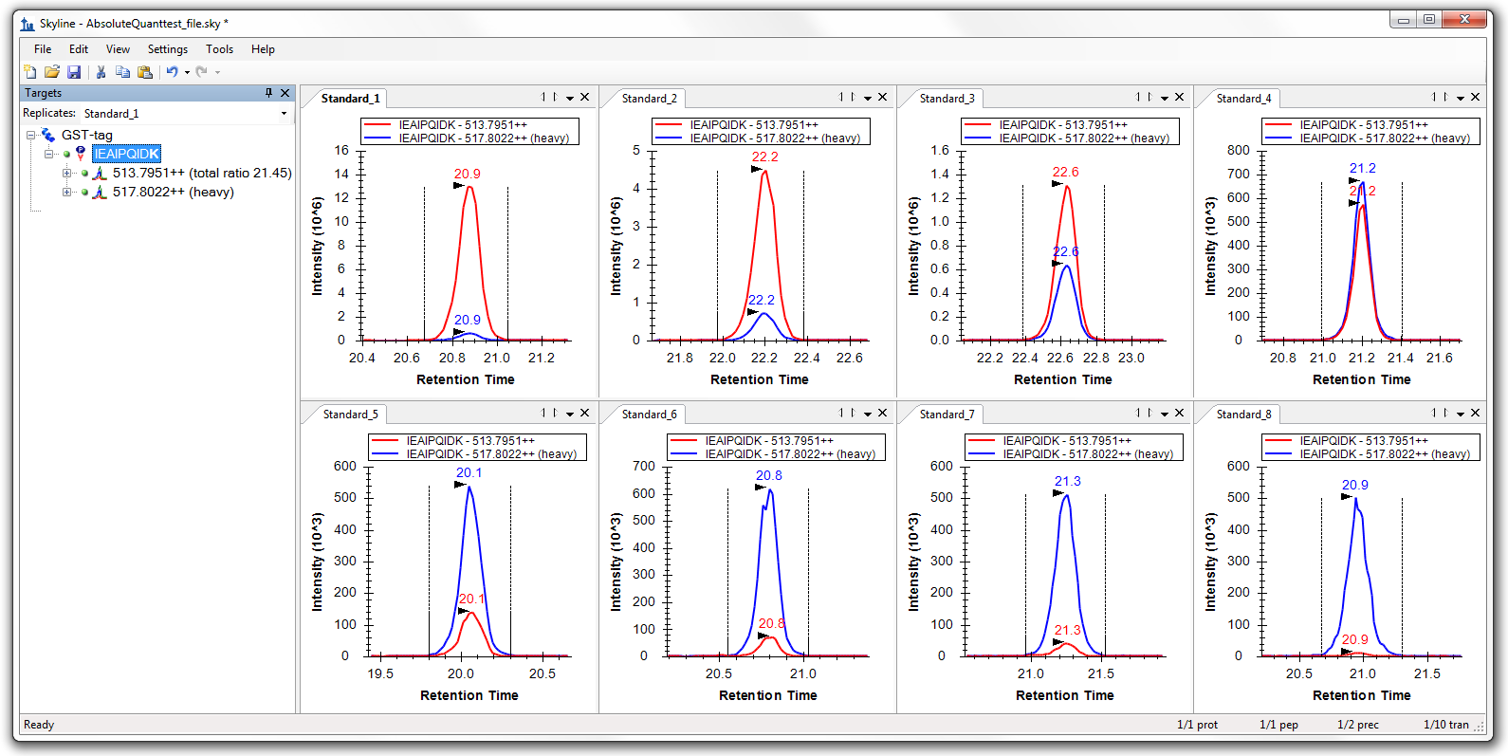

What to inspect when looking at the chromatographic traces for the standards:

* Make sure that the correct peak is selected for both the heavy and light trace of each standard.
* Make sure the peak shapes look Gaussian and do not show an excessively jagged appearance. If this is the case, it may be best to rerun your samples.
* Make sure that the retention time is similar for the different standards. Widely varying retention times often indicate poor chromatography.

# Analyzing SRM Data from FOXN1-GST Sample

Next you will want to import the FOXN1-GST.RAW file into the current Skyline document using the same instructions as detailed above. To ensure that this sample looks good, we will inspect the chromatographic trace, the fragmentation pattern and the retention time of both the heavy and light peak.

Because this is already a refined method, on the **Settings** menu, click **Integrate All**.

To focus on just the FOXN1-GST data, on the **View** menu, choose **Arrange** and click **Tabbed** (Ctrl-Shift-T), and click on the FOXN1-GST tab.

The **Retention Time** comparison graph can be displayed by pressing F8 or on the **View** menu, by choosing **Retention Times** and then clicking **Replicate Comparison**.

The **Peak Areas** comparison graph can be displayed by pressing F7 or on **View** menu, by choosing **Peak Areas** and then clicking **Replicate Comparison**.

To view the relative contribution of each transition to the total signal intensity, you can right-click on the **Peak Areas** graph, choose **Normalized To** and click **Total.**

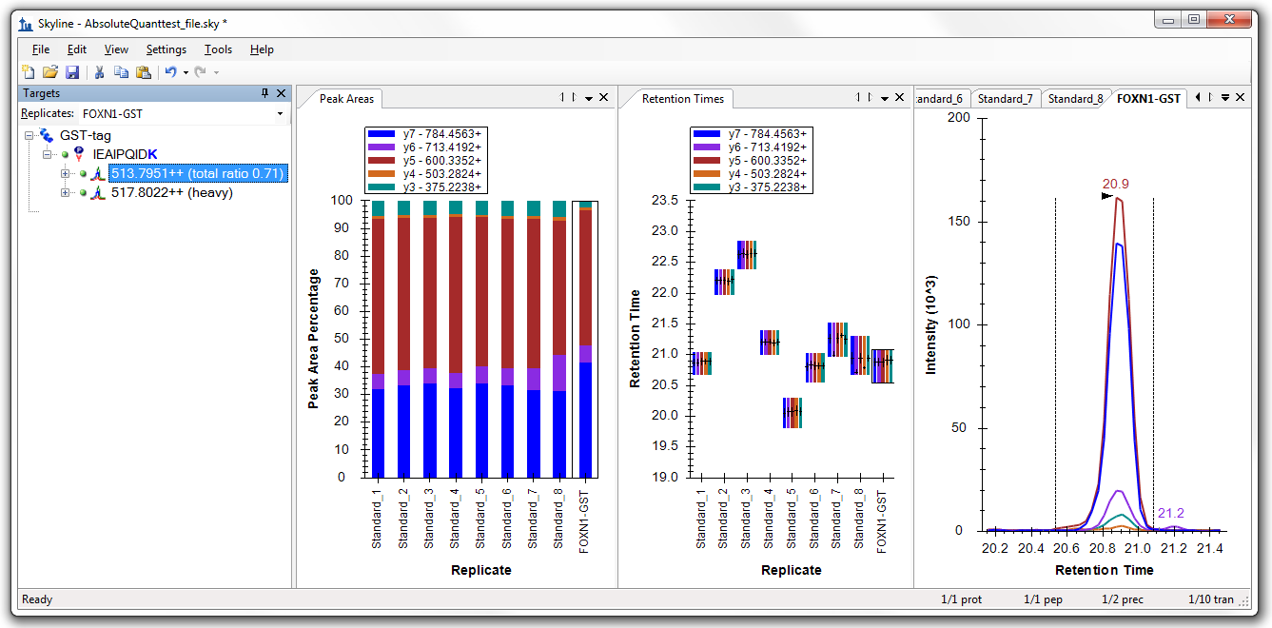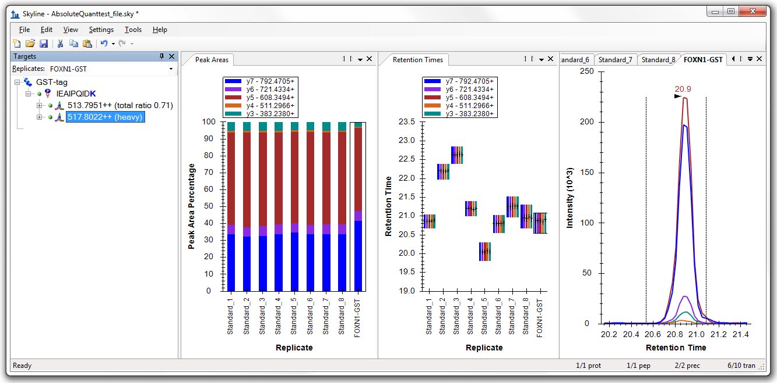

You can then select either the light or heavy precursor and inspect to ensure that:

* The correct peak is selected for both the heavy and light trace.
* The peak shape looks Gaussian and does not show an excessively jagged appearance.
* The retention time is similar for the standards and the FOXN1-GST sample.
* The relative contribution of each transition to the total signal is similar for each sample. If this does not appear to be so, then an incorrect peak is likely selected for one of the samples.

Another way to view the data is to select the IEAIPQIDK peptide in the Peptide View to the left, as opposed to the individual light and heavy precursor ions.

To view the light-to-heavy ratio for each standard and the FOXN1-GST sample, you can right-click on the **Peak Areas** graph, choose **Normalized To** and click **Heavy.**

The values displayed in this **Peak Areas** graph will be the ones we use to build our calibration curve. It can be easily observed from this graph that the light-to-heavy ratio for the FOXN1-GST sample falls somewhere in the middle of the ratios from our calibration points. This is ideal, as this portion of the calibration curve is best for quantification purposes.

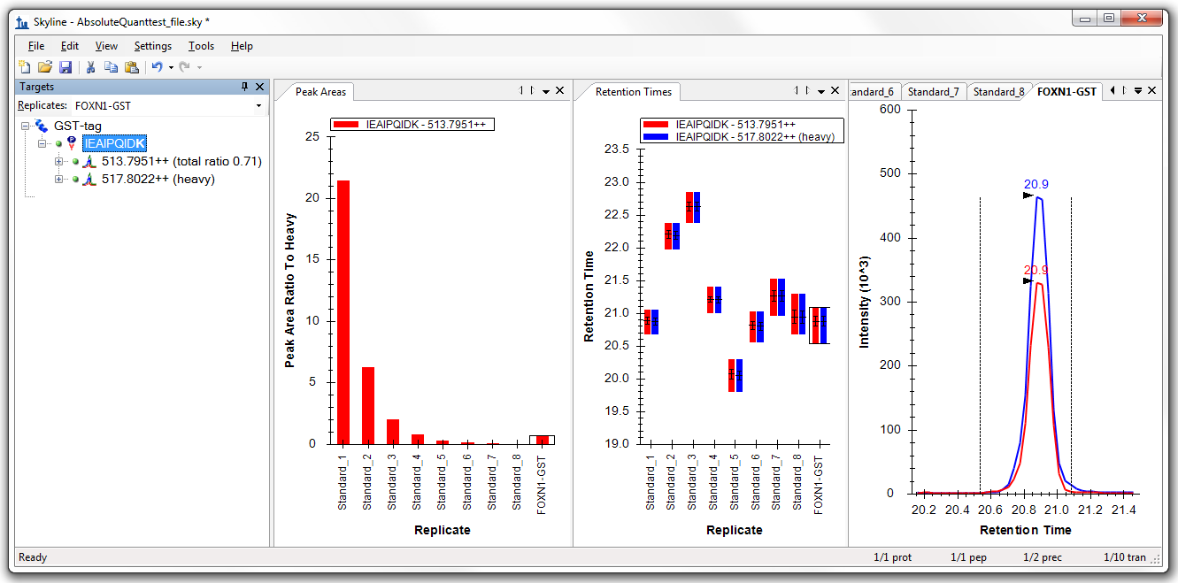

# Generating a Calibration Curve

For this tutorial, you will make a calibration curve in Skyline.

## Configuring quantification settings:

* On the **Settings** menu, choose **Peptide Settings**.
* Click the **Quantification** tab.
* Change the **Regression Fit** to **Linear**.
* Change the **Normalization Method** to **Ratio to Heavy**.
* Type **fmol/ul** into the **Units** textbox

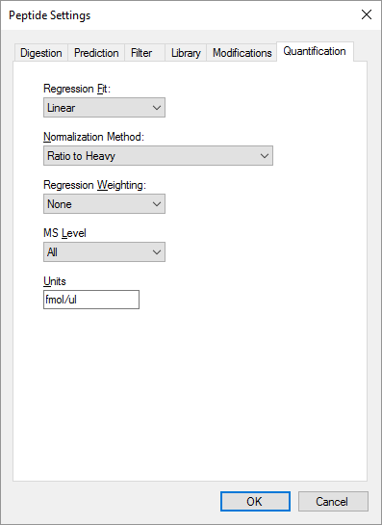

* Click **OK**

## Specify the analyte concentrations of the external standards:

* On the **View** menu, choose **Document Grid**
* At the top of the Document Grid, click the **Views** dropdown and choose **Replicates**.
* Click **OK** in the **Edit Reports** form.
* For each of the standard replicates, change the **Sample Type** to **Standard**.
* Fill in the Analyte Concentration with the values from the following table:

|  |  |
| --- | --- |
| Replicate | Analyte Concentration |
| Standard_1 | 40 |
| Standard_2 | 12.5 |
| Standard_3 | 5 |
| Standard_4 | 2.5 |
| Standard_5 | 1 |
| Standard_6 | 0.5 |
| Standard_7 | 0.25 |
| Standard_8 | 0.1 |

The Document Grid should now look like this:

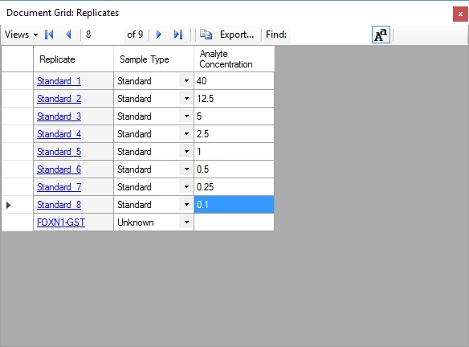

## View the calibration curve

On the **View** menu, choose **Calibration Curve**

You should see a window that looks like this:

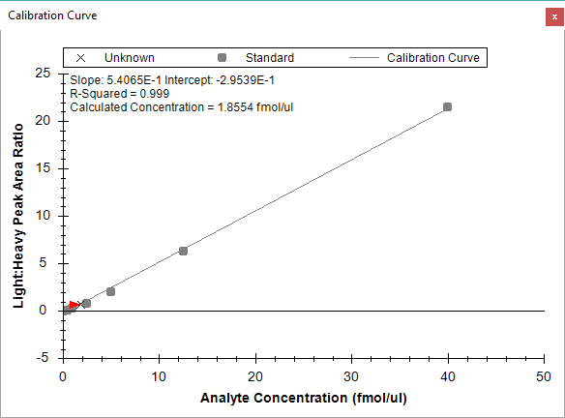

The slope and intercept are displayed on the calibration curve. They can be used to convert between peak area ratio and concentration with a standard **y = m * x + b** equation

*(concentration = slope * ratio + intercept)*

Also, calculated concentration of the currently selected replicate is displayed on the calibration form.

# Conclusion

This tutorial presented the advantages of different absolute abundance experimental setups and demonstrated how to determine absolute abundances using an external calibration curve with an internal standard heavy labeled peptide. This method provides accurate and precise absolute measurements while minimizing the amount of valuable sample that has to be used during the experiment.

# Reference List

1. Gerber, S.A., Rush, J., Stemman, O., Kirschner, M.W. & Gygi, S.P. Absolute quantification of proteins and phosphoproteins from cell lysates by tandem MS. *Proceedings of the National Academy of Sciences of the United States of America* **100**, 6940-6945 (2003).
2. MacCoss, M.J., Wu, C.C., Matthews, D.E. & Yates, J.R. Measurement of the isotope enrichment of stable isotope-labeled proteins using high-resolution mass spectra of peptides. *Analytical Chemistry* **77**, 7646-53 (2005).
3. Lavagnini, I. & Magno, F. A statistical overview on univariate calibration, inverse regression, and detection limits: Application to gas chromatography/mass spectrometry technique. *Mass spectrometry reviews* **26**, 1-18
4. Watson, J.T. Mass Spectrometry. *Methods in Enzymology* **193**, 86–106 (1990).
5. Patterson, B.W. & Wolfe, R.R. Concentration dependence of methyl palmitate isotope ratios by electron impact ionization gas chromatography/mass spectrometry. *Biological mass spectrometry* **22**, 481-6 (1993).
6. MacCoss, M.J., Toth, M.J. & Matthews, D.E. Evaluation and optimization of ion-current ratio measurements by selected-ion-monitoring mass spectrometry. *Analytical chemistry* **73**, 2976-84 (2001).
7. Stergachis, A., MacLean, B., Lee, K., Stamatoyannopoulos, J. A., & MacCoss, M. J., Rapid empirical discovery of optimal peptides for targeted proteomics *Nature Methods* In press